Why You Will Never Drive a Car Again

- Ashna Goel, Bharati Vidyapeeth College of Engineering

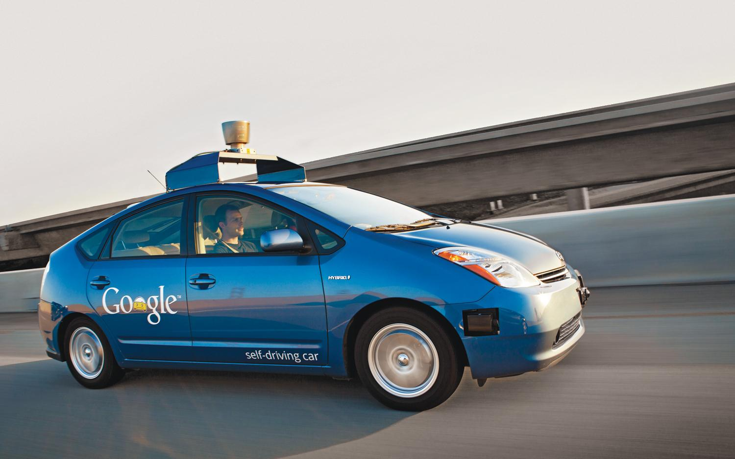

The Dream of having Driverless Cars may soon become a reality.

The fantasy of driverless cars has been with us for ages. Movies have had them, sci-fi books have described them and various companies have given it a go. It’s only now that new experiments have shown that this dream concept may soon be a reality. As always, new technology throws up equal parts of delight and despair. That’s why driverless cars may well be the greatest boon and bane of recent times.

The Google Driverless cars is a project by Google that involves developing technology for autonomous cars. The project is currently being led by Google Engineer, Sebastian Thrun, former director of the Stanford Artificial Intelligence Laboratory and co-inventor of Google Street View. Google presented a new prototype of their driverless car that had neither steering wheel nor pedals.

Autonomous vehicles sense their surroundings with techniques such as radar, LIDAR (Light Radar System), GPS, and computer vision. This laser allows the vehicle to generate a detailed 3D map of its environment. The car then takes these generated maps and combines them with high-resolution maps of the world. Advanced control systems interpret sensory information to identify appropriate navigation paths, as well as obstacles and relevant signage. This helps in producing different types of data models that allow the car to drive itself.

Google Founders Sergey Brian and Larry page came out with some thoughts on how a Driverless car would actually be used. Nobody would own these cars, just page one to pick you up wherever you were and drop you at your destination. No finding for car parking, no waste of parking space, no fighting with neighbors over wrongfully parked cars. This could revolutionize the urban planning.

**Cars for all:** Many people like children, the aged the differently abled cannot drive. Also those who cannot wrap their heads around negotiating a car and unruly traffic face terrible problems dealing with simplest commutes. Driverless cars are for all and takes care of the problem of wasted time and space.

**Radical Form Factor:** No steering wheel, no pedal, and no seat for a driver, everyone in the car is a passenger, more space, better ergonomics. A driverless car is a total reboot of the design and process of what a car is and how it is built. From seating to engine to safety standards, everything will be more efficient and usable.